## **Optimizing Behavioral Health Management with a Robust SQL Database System**

**Project Overview**

**Project Name**: Raise and Grow Database Management System

**Project Manager**: Emmanuel Atangana Seme

**Date**: December 2023

**Project Outlines**

1. Introduction
   1. Purpose
   2. Problem Statement
   3. **Expected Outcomes**
2. Project Scope
   1. Primary Focus Areas
   2. Stakeholders:
3. Current Challenges
   1. Decentralized and manual data management processes
   2. Difficulty in tracking client progress and staff performance
   3. Inefficiencies in generating compliance reports
   4. Limited scalability and adaptability of current systems
4. Database Design
   1. Key Features
   2. Relationships and Schema
   3. Creating and visualizing an Entity-Relationship Diagram (ERD**)**
5. Implementation Plan
   1. Requirements Gathering
   2. Database Design and Development
   3. Testing and Deployment
   4. Integration and Support
6. Expected Benefits
   1. Efficiency
   2. Decision-Making
   3. Care Quality
   4. Compliance
   5. Scalability

Conclusion

1. **Introduction**

Raise and Grow (RG) is dedicated to supporting adults with developmental disabilities and behavioral challenges by providing high-quality residential care and tailored programs. However, managing client data, staff schedules, program performance, and compliance reporting has become increasingly complex with existing systems. This project aims to design and implement a centralized, secure, and scalable database solution. By streamlining data processes and enhancing operational efficiency, this system will empower RG to deliver better care, track progress in real-time, and meet compliance requirements with ease, ensuring sustained growth and improved outcomes for its clients.

* 1. **Purpose**

The purpose of this project is to develop and implement a robust database system for Raise and Grow (RG) to improve the management of behavioral health services. The database will centralize client, staff, and program data, streamline operations, and provide actionable insights to support decision-making. This will enable RG to enhance care quality, reduce inefficiencies, and ensure compliance with regulatory standards.

* 1. **Problem Statement**

Raise and Grow currently faces challenges with decentralized data management and manual processes, which lead to inefficiencies, errors, and limited insights. Tracking client progress, managing staff schedules, and monitoring program outcomes are time-consuming and prone to inaccuracies. Additionally, preparing compliance reports requires significant effort, diverting valuable resources from core services. Without an integrated database, RG struggles to address these challenges effectively, impacting the quality of care and organizational efficiency.

* 1. **Expected Outcome**

The success of this project will be measured by its ability to rationalize operations and improve service delivery at RG. Key performance indicators (KPIs) include a significant reduction in time spent on manual data entry and reporting, demonstrated by a 30% improvement in operational efficiency within the first six months. Success will also be evident through enhanced care quality, tracked via a reduction in behavioral incidents and improved client outcomes, as well as timely and accurate compliance reporting with zero missed deadlines. Additionally, user satisfaction among staff and stakeholders will be monitored, with at least 85% reporting improved accessibility and usability of the system. Scalability and data security will be validated by the database’s ability to handle increased workloads and maintain data integrity without breaches or downtime.

* 1. **Sample Key Questions that can be Addressed by the Database System**

As part of the implementation of a robust database for Raise and Grow, the system is designed to resolve several critical questions that currently challenge operational efficiency and service delivery. By providing centralized data access and real-time insights, the database will enable the organization to answer pressing operational, compliance, and care-related questions:

(a) **Client Progress and Behavioral Health:**

* + What are the trends in behavioral health for specific clients, and how effective are their current intervention plans?
  + Are there recurring patterns in incidents, and how can these be mitigated?

**(b) Program Performance and Effectiveness:**

* + Which programs are delivering the most significant positive outcomes for clients?
  + What adjustments are needed in existing programs to enhance their impact?

**(c) Staff Management and Scheduling:**

* + Are staff certifications and training up to date to meet program requirements?
  + How effectively are staff members matched with clients to maximize compatibility and care quality?

**(d) Compliance and Reporting:**

* + Are all compliance reports prepared and submitted on time, with the necessary supporting data?
  + What insights can be drawn from compliance data to inform strategic decisions?

**(e) Resource Optimization:**

* + Are resources such as staff hours and funding being used efficiently across programs?
  + What improvements can be made to balance workloads and ensure consistent coverage?

**(f) Client Placement and Compatibility:**

* + How successful have recent client placements been in terms of reduced behavioral incidents and improved client satisfaction?
  + Which available placements are best suited to meet the needs of incoming clients?

**(g) Operational Efficiency and Growth:**

* + What bottlenecks in data management have been resolved since implementing the database?
  + How can the system scale support the organization’s growth and new program development?

1. **Project Scope**

**2.1 Primary Focus Areas**

The project will centralize data management by consolidating client, staff, program, incident, and resource data into a single, secure platform, ensuring easy access and efficient handling. It will automate key processes such as incident reporting, progress tracking, and compliance reporting, reducing manual effort and minimizing errors. Behavioral health monitoring will be enhanced through real-time tracking of client behavior patterns and outcomes, enabling timely and effective interventions. The database will be designed to scale with the organization’s growth, ensuring flexibility to accommodate new programs and increased data. Additionally, it will support compliance by providing automated tools for accurate and timely reporting to regulatory bodies. Finally, data security and privacy will be prioritized with role-based access control and robust encryption to safeguard sensitive information.

**2.2 Stakeholders**

The stakeholders benefiting from this project include clients, whose data will be securely managed to ensure personalized care and better outcomes. Direct Support Professionals (DSPs) will use the system to access client profiles, report incidents, and manage schedules more efficiently. Program managers and specialists will monitor program effectiveness and update behavior plans based on real-time data. Behavior specialists will leverage the system’s insights to refine strategies and provide timely interventions. Administrative staff will streamline resource allocation, staff certifications, and compliance reporting. Regulatory bodies like DSHS and DDA will receive accurate and timely reports, ensuring adherence to standards. Finally, the leadership team will utilize database insights for strategic planning and organizational development.

**3. Current Challenges**

3.1 Decentralized and Manual Data Management Processes

Raise and Grow currently relies on scattered and manual methods for managing critical data, with client, staff, and program information stored in multiple locations and formats. This decentralization results in inconsistencies, data redundancies, and inefficiencies, making it difficult to retrieve accurate information in a timely manner.

3.2 Difficulty in Tracking Client Progress and Staff Performance

The absence of a centralized system creates significant challenges in monitoring client outcomes and evaluating staff effectiveness. Tracking behavioral trends, progress in support plans, and staff compliance with certifications or training schedules is cumbersome and often incomplete, leading to missed opportunities for timely interventions and improvements.

3.3 Inefficiencies in Generating Compliance Reports

Preparing reports for regulatory bodies such as DSHS and DDA is a time-consuming and error-prone process due to the reliance on manual data compilation. These inefficiencies increase the risk of inaccuracies, delays, and potential non-compliance, diverting valuable resources away from core operations.

3.4 Limited Scalability and Adaptability of Current Systems

The existing systems are not designed to scale with the organization's growth or adapt to new programs and evolving needs. As Raise and Grow expands its services, the current infrastructure struggles to accommodate increased client data, staff records, and program requirements, hindering operational efficiency and organizational development.

**4. Database Design**

**4.1 Key Features**

The database system will include several essential features to streamline operations and improve efficiency. A centralized data repository will consolidate all clients, staffs, programs, and resource information into a single platform for easy access and management. The system will automate key processes such as incident logging, progress tracking, and compliance reporting, reducing manual workload and minimizing errors. Role-based access control will ensure data security, allowing only authorized users to access sensitive information. Real-time dashboards and reporting tools will provide actionable insights, enabling timely decision-making. The system will also be designed to scale seamlessly, accommodating organizational growth and new program requirements while maintaining high performance.

**4.2 Relationships and Schema**

The database design will follow a relational structure with well-defined entities and relationships to ensure data consistency and integrity. Key entities include:

* **Clients Table**: Stores personal details, medical history, behavioral profiles, and program placements, linking to incidents and behavior plans.
* **Staff Table**: Maintains staff details, certifications, training records, and program assignments, linked to clients and programs.
* **Programs Table**: Tracks program details, client placements, and associated staff, with relationships to behavior plans and incidents.
* **Table Incidents**: Logs behavioral incidents, linked to specific clients and staff for detailed analysis.
* **Behavior Plans Table**: Stores personalized intervention plans and progress notes, tied to client profiles.
* **Resources Table**: Lists external affiliations, training materials, and related program resources.
* **Compliance Reports Table**: Tracks compliance documentation and reporting timelines, linked to programs and regulatory requirements.

The schema is designed to establish relationships between these entities, ensuring data is interconnected and accessible for comprehensive analysis. For example, a query can retrieve a client’s progress, their associated behavior plan, and the staff involved in their care, providing a complete picture in one view. This relational approach supports both operational needs and strategic decision-making.

**4.3 Creating an Entity-Relationship Diagram (ERD)**

Relationships between entities:

* + **Clients** to **Programs**: One client belongs to one program (1:N).
  + **Staff** to **Programs**: Staff can work in multiple programs (M:N).
  + **Incidents** to **Clients**: Incidents are related to a specific client (1:N).
  + **Behavior_Plans** to **Clients**: Each client can have multiple behavior plans (1:N).
  + **Programs** to **Resources**: Programs may use multiple resources (M:N).
  + **Programs** to **Compliance_Reports**: Programs generate multiple compliance reports (M:N).

**Visualizing the Entity-Relationship Diagram (ERD) using dbdiagram.io Tool**

1. **Implementation Plan**

**5.1** Requirements Gathering

The first phase of the implementation plan involves gathering and analyzing requirements to ensure the database system meets organizational needs. This includes collaborating with stakeholders such as program managers, staff, and administrators to identify critical data points like client profiles, program details, incidents, and compliance requirements. The process involves documenting existing workflows, understanding pain points in current data management practices, and defining the desired outcomes, such as improved data accessibility, automated reporting, and streamlined operations. This phase ensures that the database structure, functionality, and features are aligned with operational goals and regulatory obligations.

* 1. **Database Development**

The database development phase focuses on designing and building a robust relational database system based on the requirements gathered. This includes creating the schema with properly structured tables, defining relationships between entities (e.g., clients and programs), and enforcing data integrity through constraints such as primary and foreign keys. During this phase, initial data is populated, and queries, views, and stored procedures are developed to support the system's functionality. The goal is to create a scalable and secure database that meets operational and reporting needs.

* 1. **Views and Stored Procedures**
* **Views**

Views are virtual tables that simplify complex queries and provide a user-friendly way to access data. They are particularly useful for creating reports and managing frequently accessed data. For instance, the following view script lists Clients and their current programs.

Now, we can the output of the Clients Programs View after it has been successfully created can be obtained using the following SQL query:

And we get the following output

And the “SELECT * FROM IncidentSummaryView” statement provide the following output:

* **View of the Incidents and Client Details**

This view details incident reports, including the client’s name, date of birth, incident type, and follow-up actions. The output is as follows

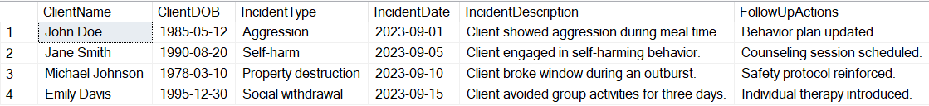

* **Behavior Plans and Client Details**

The view Lists behavior plans for each client, including the plan creation date, details, and progressnotes.

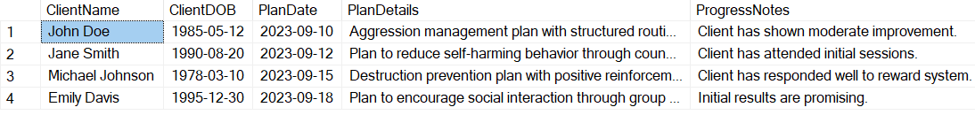

Likewise, we create the view of all the other tables. To create the view for the View for Incident Summaries, we use the following script:

This view simplifies incident reporting by summarizing incident details by client.

* **Resources and Program Details View**

The view provides information about resources and the programs they are associated with, including resource type and descriptions. Its output is as follows:



* **Compliance Reports and Program Details**

This view Displays compliance reports for each program, including the report date and compliance details.

* 1. **Testing and Deployment**

Through the process of testing, we ensure that the database system meets all functional, performance, and security requirements. For that step, we perform a variety of tests should:

* Functional Testing**:** We verify that all tables, views, and stored procedures work as expected.
* We do the Test CRUD (Create, Read, Update, Delete) operations on each table.
* Validate relationships between tables, such as foreign key constraints.
* Test all views by running SELECT queries to ensure they return accurate data.

**5.4.1 A few series of Tests**

First, we insert a new client into the Clients table and assign them to an existing program using the CurrentProgramID.



Then, we verify that the client was successfully added and linked to the correct program by running the ClientsProgramsView.



The following output shows that the client Anna Taylor’s details are included, along with the name and description of the program with ProgramID = 1.

Likewise, we insert a new incident into the Incidents table for an existing client, and we write a Query the IncidentsDetailsView to confirm the incident appears with the correct client details as shown below.



The output below includes the details of the incident (e.g., date, type, description, and follow-up actions) along with John Doe's information.

To test the Performance of the database, run at least one complex query. For instance, we can run a query involving multiple joins and large datasets.

A portion of the output is shown below.

The query returns all relevant clients, program, incident, and behavior plan details for programs that started before December 31, 2023. Additionally, the execution time is within an acceptable threshold (e.g., under 1 second for small datasets).

* **Test Under High Load Conditions**

The next test is Under High Load Conditions. We simulate simultaneous inserts and queries to evaluate the performance of the database underload.

We notice that the Inserts is completed within a reasonable time frame without causing deadlocks or significant performance degradation. In addition, the query performance remains consistent even under simultaneous executions.

* **Data Integrity Testing**

First, we test the Primary Key Constraints to ensure that primary key constraints prevent duplicate entries in tables. This can be done by an attempt to insert a record into the Programs table with a duplicate ProgramID (if manually set)



We get the following results meaning that the database rejects the insertion with an error



Second, we test the Foreign Key Constraints to ensure that the foreign key constraints prevent invalid relationships. This can be done in two tests: on the first test, we insert a Client with a Non-Existent ProgramID as follows:



We obtain the following error message:



For the second test, we attempt to delete a program that is currently referenced by a client in the Clients table as follows:



We obtain the following error message:



* **Data Type Constraints Test**

The test ensures that only valid data types are accepted in columns. We can do this test by attempting to insert invalid data into a date field (e.g., DOB) as follows:



The database rejects the insertion with the following error:

* **Test NOT NULL Constraints**

This test ensures that NOT NULL constraints prevent missing critical data. This test can be executed by attempting to insert a record into the Clients table without providing a Name as follows:

* **Security Testing**

The first security test is to Validate “Role-Based Access Control”, that is, ensure that users have appropriate permissions based on their roles and are restricted from accessing unauthorized data or performing unauthorized actions. For this, we create or define roles with specific access rights. For example:

Then, we assign or grant permission to each role on the database objects:

Then, we assign Roles to Users, that is, we add database users and assign them to roles:

We obtain the following error message

1. **Sample Problems Scenarios that could be addressed Using this Database**

The database is designed to address various operational challenges and support advanced analytics by providing structured, queryable data. By leveraging SQL's powerful features, the database enables users to extract valuable insights, automate processes, and enhance decision-making. This section presents real-world scenarios where SQL techniques such as joins, filtering, subqueries, and aggregate functions solve complex problems, demonstrating the database's utility in streamlining operations and driving data-driven outcomes.

**a. Using LIKE**

**Scenario:** Find clients with names starting with "J".

The output is

**b. Using INNER JOIN**

**Scenario:** List all clients and their current program details.

An INNER JOIN combines rows from the Clients and Programs tables based on a matching condition. The condition specified is: “Clients.CurrentProgramID = Programs.ProgramID”. This ensures that only rows where a CurrentProgramID in the Clients table matches a ProgramID in the Programs table are included in the result. The portion of the output is

**c. Using LEFT JOIN**

**Scenario:** Find all programs and the clients associated with them, including programs without any clients.

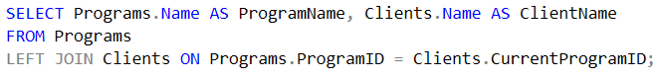

This SQL query uses a RIGHT JOIN to combine data from the Clients and Programs tables, ensuring that all rows from the Programs table are included, even if they do not have a matching record in the Clients table. The portion of the result is shown below:

**d. Using RIGHT JOIN**

**Scenario:** List all clients and their assigned programs, even if a client is not currently assigned to a program.

The A RIGHT JOIN ensures that **all rows from the Programs table** appear in the result, even if there is no matching CurrentProgramID in the Clients table. If no client is associated with a particular program, columns from the Clients table will show NULL.

The portion of the output is :

**e. Using CROSS JOIN**

**Scenario:** Create a combination of all programs and all resources to analyze potential program-resource assignments.

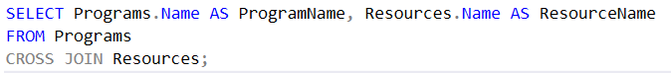

The A CROSS JOIN generates all possible combinations of rows from the two tables. If the Programs table has 3 rows and the Resources table has 4 rows, the result will have 3×4 = 12 rows. The result is:

**f. Using FULL JOIN**

**Scenario:** Show all programs and clients, including unassigned programs or clients.

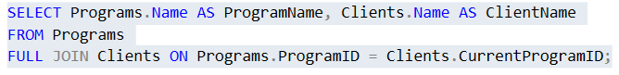

The Full Join combines rows from both tables. It includes all rows from the Programs table, even if there are no matching rows in the Clients table, and also all rows from the Clients table, even if there are no matching rows in the Programs table. If no match exists, the corresponding columns from the unmatched table will be NULL. The portion of the output is shown below:

**g. Using COUNT**

**Scenario: Count the total number of clients enrolled in each program.**

The output is

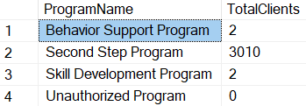

**12. Using AVERAGE, SUM**

**Scenario:** Calculate the average number of incidents per client and the total number of incidents recorded.

This query calculates the average number of incidents per client as well as the total number of incidents. The output is displayed below:

**13. Using Aggregate Functions**

**Scenario: Finding the Earliest and Latest Incident Dates for a Given Client named John Doe**

This query helps in understanding the history of a client, which can be critical for creating tailored behavior plans or tracking progress over time.

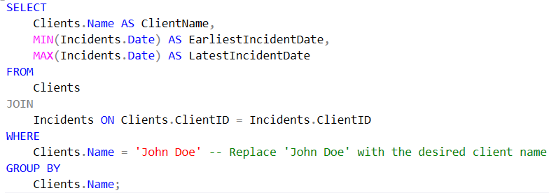

The output is as follows:

**15. Using a Subquery**

**Scenario:** List of all programs with more than 2 clients enrolled.

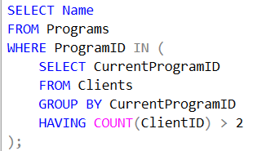

The result is the following:

**16. Using Window Functions**

**Scenario:** Rank clients by the number of incidents they have.

The portion of results is displayed below:

**17. Using IF**

**Scenario:** Categorize clients based on the number of incidents they have.

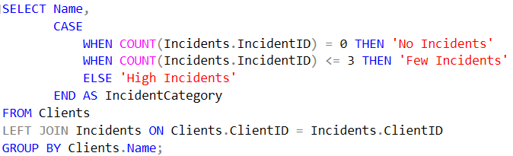

The portion of the output is the following:

**18. Using Complex Queries**

**Scenario:** List of clients with their program details and the count of incidents, ordered by the number of incidents.

The partial of the results is the following:

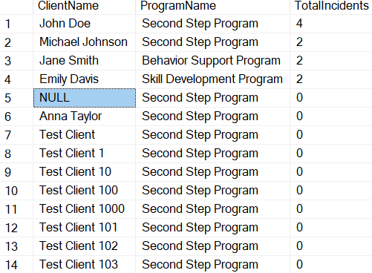

**6. Expected Benefits**

The implementation of this project brings numerous advantages that span across operational efficiency, decision-making, quality of care, regulatory compliance, and scalability. By leveraging optimized processes, data-driven insights, and advanced tools, organizations can streamline workflows, enhance patient outcomes, and meet both current and future needs. The following subsections outline the specific benefits anticipated from this initiative.

**6.1 Efficiency**

Efficiency is one of the core benefits of this project, as it aims to streamline workflows and automate repetitive tasks. By minimizing manual interventions, the likelihood of errors is reduced, allowing for faster and more accurate data processing. The optimized processes ensure that resources such as time and effort are utilized effectively, freeing up staff to focus on higher-priority tasks. Additionally, improved data retrieval mechanisms make it easier for users to access critical information promptly, thereby enhancing overall productivity and operational performance.

**6.2 Decision-Making**

Improved decision-making is another significant outcome, driven by the availability of accurate, real-time data. The integration of advanced analytics and reporting tools provides actionable insights that enable organizations to make data-driven decisions confidently. Predictive models further support proactive strategies, helping to identify trends, patterns, and areas requiring intervention. With enhanced visibility into key performance metrics, stakeholders can make timely and informed decisions that drive organizational success and improve outcomes.

**6.3 Care Quality**

The project directly contributes to improved care quality by ensuring the accuracy and reliability of patient data. Streamlined data management enables healthcare providers to access comprehensive and up-to-date records, leading to better diagnoses and treatment plans. Predictive analytics also play a vital role in identifying at-risk patients, allowing for timely interventions and preventive care. By reducing administrative burdens, healthcare professionals can dedicate more time to patient care, ultimately enhancing satisfaction and outcomes for both patients and providers.

**6.4 Compliance**

Compliance with regulatory requirements is a critical benefit of this project, ensuring adherence to industry standards and legal frameworks such as HIPAA, GDPR, and other applicable guidelines. Robust data management practices, including secure access controls and audit trails, provide transparency and accountability in operations. The system helps mitigate risks associated with non-compliance, such as penalties and reputational damage, by maintaining data integrity and enabling accurate reporting. This proactive approach to compliance builds trust and confidence among stakeholders.

**6. Expected Benefits**

The implementation of this project brings numerous advantages that span across operational efficiency, decision-making, quality of care, regulatory compliance, and scalability. By leveraging optimized processes, data-driven insights, and advanced tools, organizations can streamline workflows, enhance patient outcomes, and meet both current and future needs. The following subsections outline the specific benefits anticipated from this initiative.

**6.1 Efficiency**

Efficiency is one of the core benefits of this project, as it aims to streamline workflows and automate repetitive tasks. By minimizing manual interventions, the likelihood of errors is reduced, allowing for faster and more accurate data processing. The optimized processes ensure that resources such as time and effort are utilized effectively, freeing up staff to focus on higher-priority tasks. Additionally, improved data retrieval mechanisms make it easier for users to access critical information promptly, thereby enhancing overall productivity and operational performance.

**6.2 Decision-Making**

Improved decision-making is another significant outcome, driven by the availability of accurate, real-time data. The integration of advanced analytics and reporting tools provides actionable insights that enable organizations to make data-driven decisions confidently. Predictive models further support proactive strategies, helping to identify trends, patterns, and areas requiring intervention. With enhanced visibility into key performance metrics, stakeholders can make timely and informed decisions that drive organizational success and improve outcomes.

**6.3 Care Quality**

The project directly contributes to improved care quality by ensuring the accuracy and reliability of patient data. Streamlined data management enables healthcare providers to access comprehensive and up-to-date records, leading to better diagnoses and treatment plans. Predictive analytics also play a vital role in identifying at-risk patients, allowing for timely interventions and preventive care. By reducing administrative burdens, healthcare professionals can dedicate more time to patient care, ultimately enhancing satisfaction and outcomes for both patients and providers.

**6.4 Compliance**

Compliance with regulatory requirements is a critical benefit of this project, ensuring adherence to industry standards and legal frameworks such as HIPAA, GDPR, and other applicable guidelines. Robust data management practices, including secure access controls and audit trails, provide transparency and accountability in operations. The system helps mitigate risks associated with non-compliance, such as penalties and reputational damage, by maintaining data integrity and enabling accurate reporting. This proactive approach to compliance builds trust and confidence among stakeholders.

**6.5 Scalability**

Scalability ensures that the project can adapt to growing organizational demands and evolving technologies. The infrastructure is designed to handle increasing data volumes and accommodate more users without compromising performance. The system's flexibility allows seamless integration with other tools and platforms, ensuring future compatibility and functionality expansion. This ability to scale effectively prepares the organization for long-term growth, enabling it to meet current challenges while being ready to embrace future innovations and opportunities.

Conclusion

This project initiative serves as a comprehensive solution to current challenges while laying a strong foundation for future success. It empowers Raise and Grow organization to remain competitive, responsive, and efficient in an ever-evolving environment, driving meaningful and sustainable outcomes.